Little SPARK: Simple Play Adaptations to Reference for Kids

Tangle Junior
Description: | Image:
Tangle Jr. is small, smooth and colorful. It has multi-colored segments that are joined together to twist, turn, and move. It can be used with one or two hands together. This is considered a quiet fidget.  Purchasing Information | 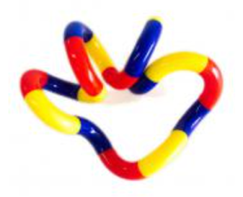

Who Might Benefit?
For those who need support with self-regulation, sensory input, or focus through fidgeting, or seeking tactile engagement to calm themselves or maintain attention.
Why Use?
Self-regulation, quiet self-calming activities, tactile exploration, improved fine motor skills and grip strength, and focused fidgeting.
Instructions for Use: | Adaptation Ideas:
Environmental Considerations  - Use in all settings and in group and one-on-one activities.  Positioning  - Use in any position; seated, standing, on the floor, etc.  Basic Play/Use  - Open ended exploration (ex. touch, twist, pull, squeeze). | Contain It  - Place ball in sensory bin or attach straps to secure on chair, etc.  Communication Supports  - Visual supports like communication cards and social narratives can help a child communicate their feelings.  DIY Alternatives  - Inexpensive stretchy headband, add your own sensory cues.

Words to Encourage Play/Use
Push   | Pull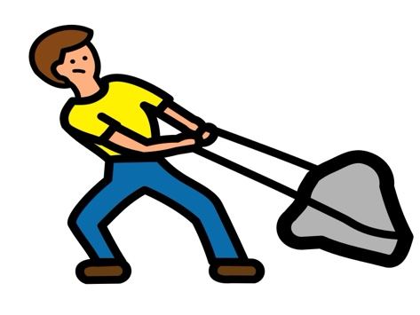 | Squeeze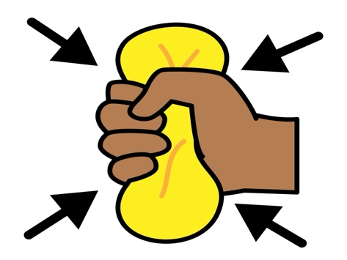
Twist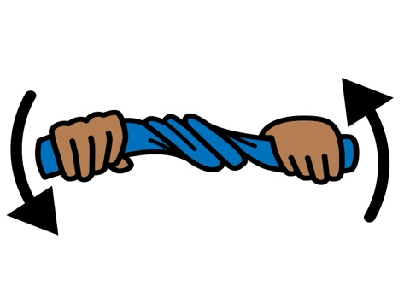 | Quiet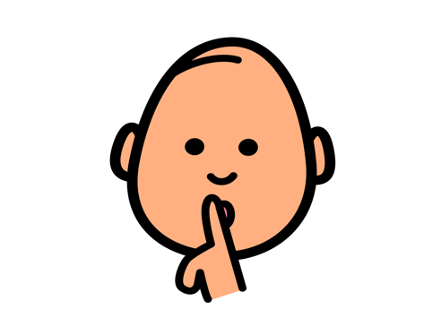 | Calm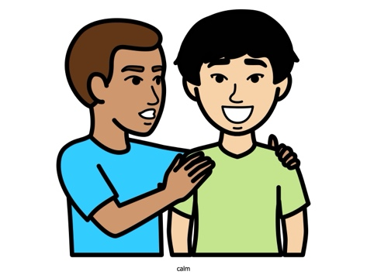
Anxious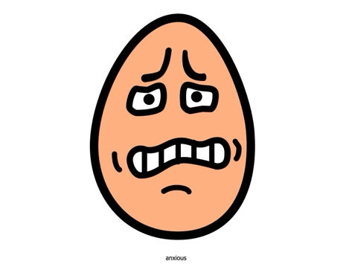 | Angry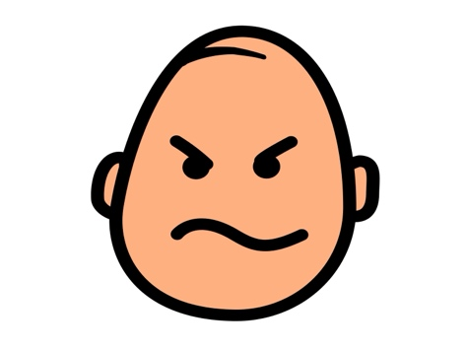 | Help  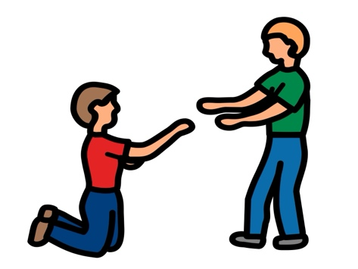
*”Adaptations” adapted from: Haugen’s Modes for Adapting Toys based on materials from the "Let's Play" Project at the University of Buffalo
PCS is a trademark of Tobii Dynavox, LLC. All rights reserved. Used with permission.

